BODY FITNESS PREDICTION

**1.Introduction**

1.1 Overview: 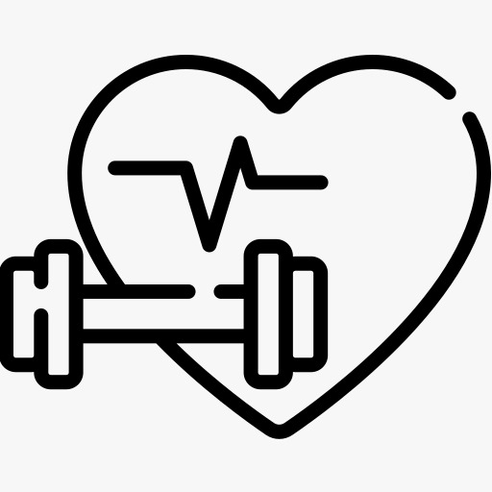

Sedentary lifestyle is defined by the absence of physical activity practices throughout the day and causes a decrease in caloric expenditure. This behavior is explained by the inappropriate lifestyle, for example, too much time sitting or lying down and still eating unhealthy foods during this time of immobilization. Currently, a third of the adult world population is physically inactive and this generates 5 million deaths per year (The LAncet, 2012). In addition to contributing to several chronic diseases, physical inactivity also influences mood, sleep quality and body weight

The objective of the project is answering a simple question, “does exercise/working-out improve a person’s activeness?”. For the scope of this project a person’s activeness was the measure of their daily step-count (the number of steps they take in a day). We are going to build a Machine Learning model which predicts the activeness or inactiveness of a person based on the Mood and number of steps taken in a day. Mood was measured in either "Happy", "Neutral" or "Sad" which were given numeric values of 300, 200 and 100 respectively. Feeling of activeness was measured in either "Active" or "Inactive" which were given numeric values of 500 and 0 respectively.

1.2 PURPOSE

To avoid this health issues, we should monitor our body fitness by using various fitness prediction gadgets like smart watches, oximeter, B-P machine etc. we can monitor our B-P, calories burnt, bone weight etc. the devices work with smart device technology to exchange data via Bluetooth communication protocol. Here, in this project we import the data which consist of (date, step-count, mood, calories burned, hours of sleep, bool of active, weight in kg) split the dataset into testing set

and training set. We are using random forest classifier in this project.

2.LITERATURE SURVEY

2.1 Existing problem

Body fitness prediction play’s a key role in leading a healthy life. Fitness is a state of health and well-being, more specifically the ability to perform daily activities body fitness is generally achieved through proper nutrition and physical exercise and resting. People are spending more and more time doing sedentary activities. During our leisure time, we are often sitting using computer or other device. By this we are losing our body fitness and it leads to various chronic issues

2.2 Proposed solution

Importing Dataset

Exploratory Data Analysis ]: df.shape

Here, in this project we import the data which consist of (date, step-count, mood, calories burned, hours of sleep, bool of active, weight in kg) split the dataset into testing set and training set. We are using random forest classifier in this project

3.THEORITICAL ANALYSIS

3.1 Block diagram

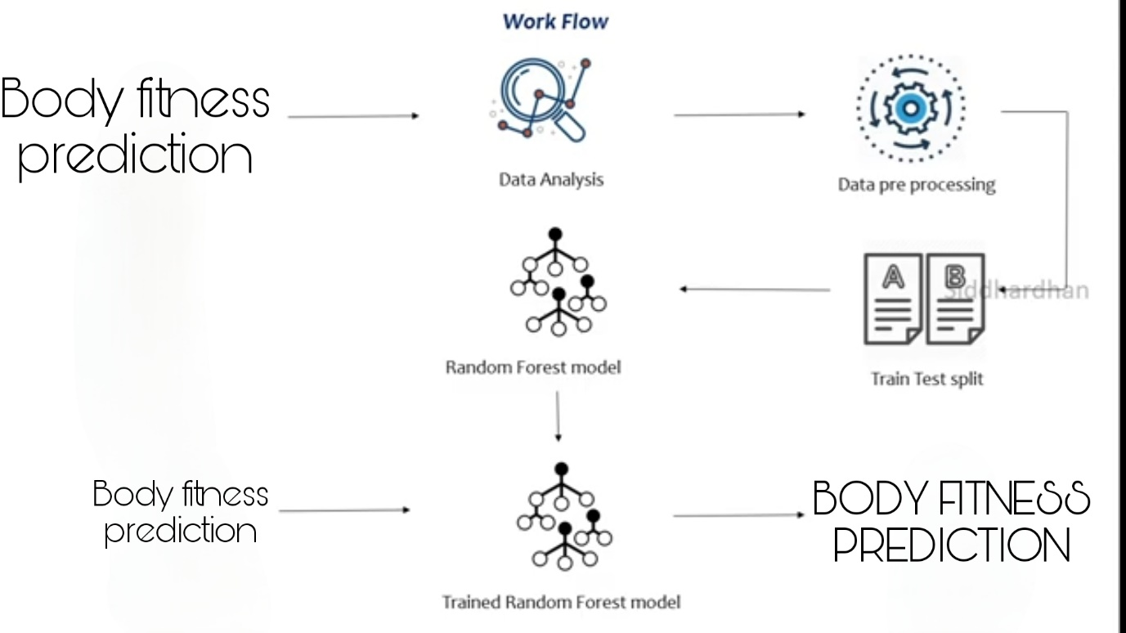

**4.EXPERIMENTAL INVESTIGATIONS**

**Dataset:**

We will use body fitness prediction dataset which was retrived from Kaggle.com.

* Check if there are associations between physical activity (by counting steps), caloric expenditure, body weight hours of sleep and the feeling of feeling active and / or inactive.
* Compare caloric expenditure between the categories of mood and self-perceived activity (active and inactive)
* Compare the hours of sleep between the categories of mood and self-perceived activity (active and inactive)
* Compare body weight between categories of self-perceived activity (active and inactive)
* Database The database has 96 observations, 7 columns. Its quantitative variables are "number of steps" (step_count), "caloric expenditure" (calories_burned), "hours of sleep" (hours_of_sleep and "body weight" (weight_kg). And qualitative variables "dates" (date), "mood" "(mood), self-perceived activity" active or inactive "(bool_of_active). The variable" humor "was assigned the value" 300 "to mean" Happy ", the value" 200 "for" Neutral "and" 100 "for" sad "and for the variable" self-perceived activity
* Quantitative variables will be expressed in means and standard deviations
* Contingency tables of categorical variables will be exposed.
* A correlation matrix between variables will be presented
* Bar charts and violins to demonstrate the distribution of quantitative variables by categories
* Scatter plot for analysis of possible linear relationship between two variables

FLOW CHART

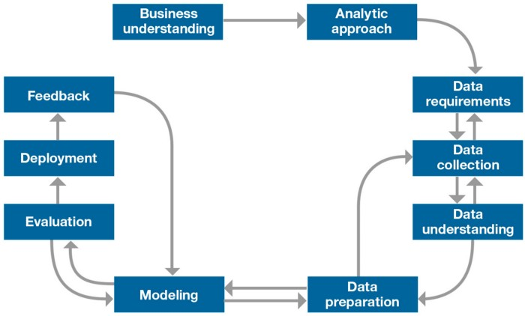

**RESULT**

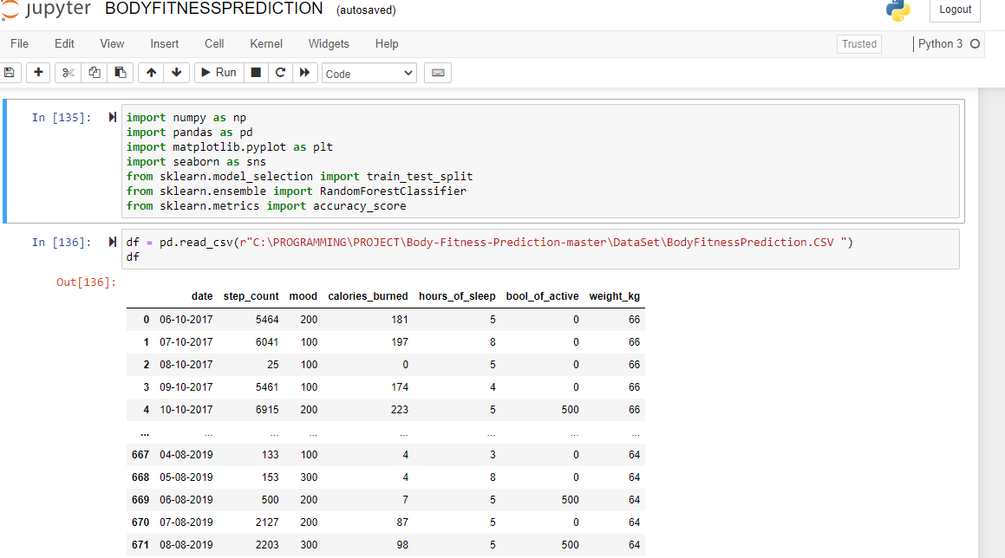

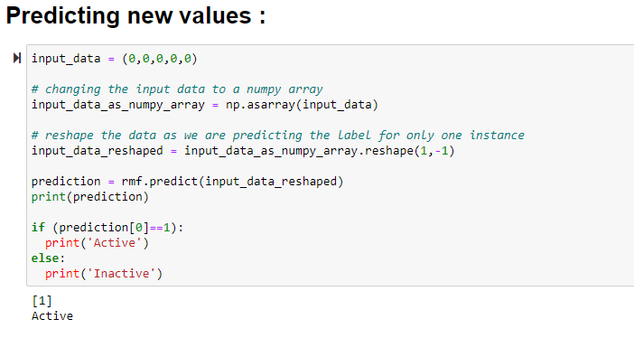

**RANDOM FOREST CLASSIFIER**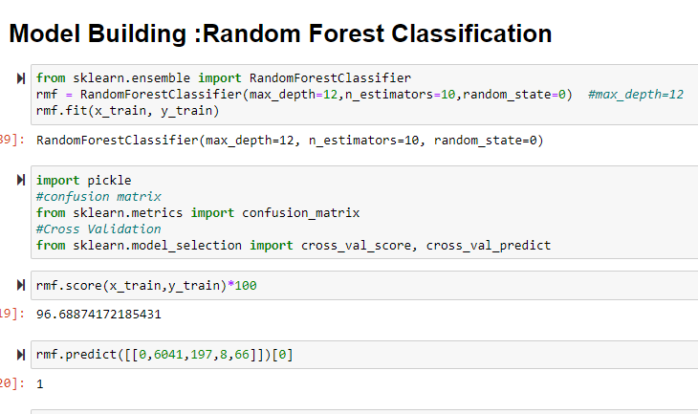

CORRELATION PLOT

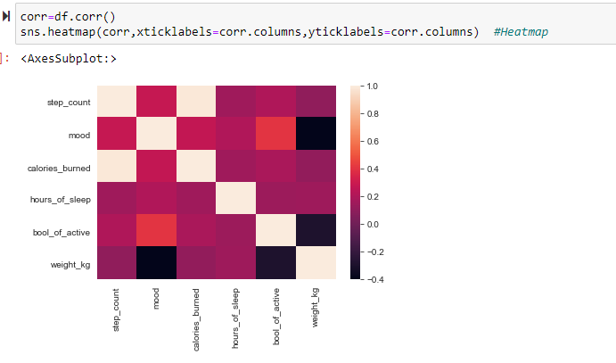

FINAL RESULT:

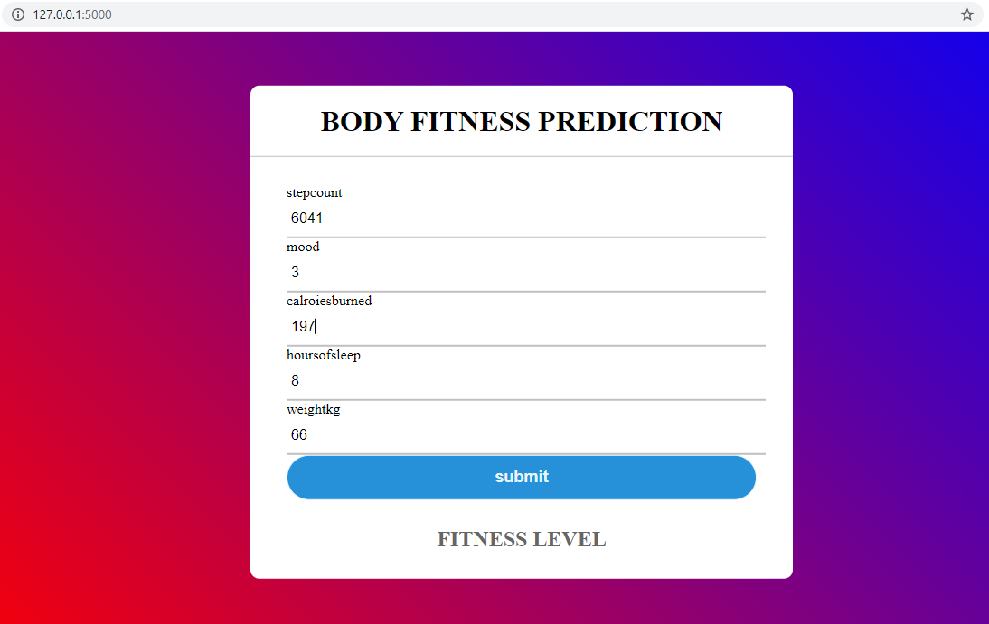

ADVANTAGES & DISADVANTAGES

we reduce this lot’s of effort we will predict that is a person is active/fit or not we have to use some parameters like mood and sleeping hours to predict whether the person is active or not. The persons daily activity determines the fitness of Body. One way of reducing the wait time and reducing the number of combinations to try is to make use of digital simulations, where we can provide information to the computer about what we know and the computer tries different combinations to predict the Body Fitness Prediction

APPLICATIONS

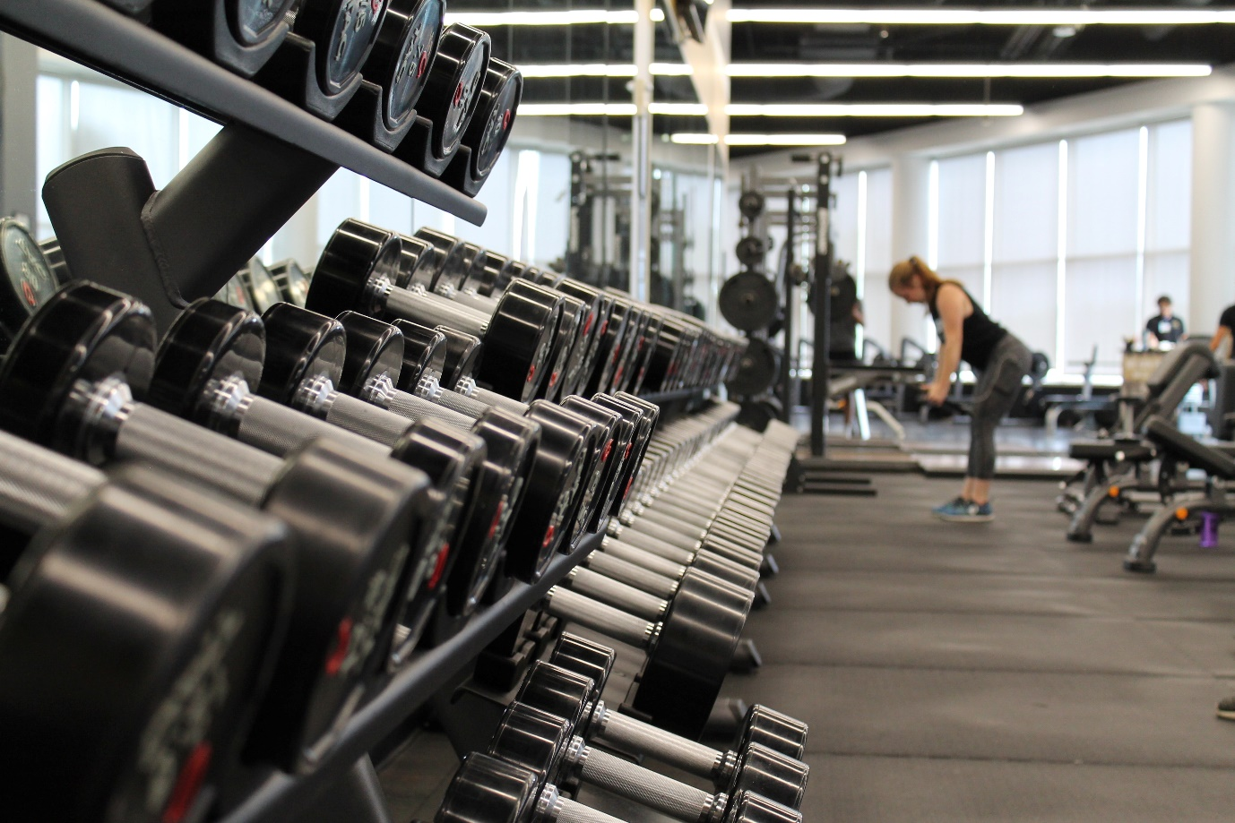

There are so many different kinds of applications used to predict the fitness of Human beings today,

A lot of technology has been improved due to improve in technology he app, which has evolved into an all-inclusive healthcare platform, has several other features that could be a draw for many. This includes live and interactive sessions with fitness coaches, at-home lab test facilities, a health store, unlimited cloud storage to organise health records, and the opportunity to donate to a cause by merely walking.

* FitnessAI
* This app uses artificial intelligence to create personalised weight lifting plans for its users. How does it work? The app has tools built into its system that optimises sets, reps and weight for each exercise, each time.
* The algorithm tells users how long they should rest for and makes recommendations around how to adjust the difficulty level for subsequent times. The app also gives clear insights by tracking your progress over time

A leading health and fitness app in India, HealthifyMe’s artificial intelligence-based virtual assistant ‘Ria’ attends to its users’ queries around fitness and nutrition, in as many as ten languages. The bot also makes dietary recommendations after factoring in the users’ data and other health parameters. Being compatible with popular fitness wearables, the app uses data mined from these devices to build an algorithm that can easily be accessible by its users.

The company made a deliberate push towards AI-powered services last year. Until then, it was popularly used to log and track calorie intake, get access to healthy recipes and tips for overall well being.

##### CONCLUSION

We have analysed the Body fitness prediction Data and used Machine Learning to Predict the fitness of a human being. We have used Random forest classifier and its variations, to make predictions and compared their performance. Xgboost regressor has the lowest RMSE and is a good choice for this problem. Also, we can further improve the performance of the algorithm by tuning the hyperparameters by performing a grid search or random search. This way we can reduce the number of combinations we can try physically and reduce the amount of time for experimentation. It is possible to derive mathematical equations and run simulations based on these equations, but we cannot expect the relations to be same in real-world. Also, these tests have been performed for many numbers of times now and we have enough real-world data that can be used for predictive modelling

### Future Scope

If the year 2020 has taught us anything, it’s that our health takes priority.

In addition to the many societal changes of last year, the way we exercise has changed, too. With more people staying at home without access to gyms, the fitness landscape has transformed dramatically.

With 2021 upon us, we can expect to see even more changes to fitness

Culture .

**1. Home gyms**

According to a recent poll of 2,000 people by OnePoll, [75% of people](https://nypost.com/2020/07/16/survey-says-the-at-home-workout-is-here-to-stay-even-if-covid-19-disappears/) believe it’s easier to stay fit at home. Since the COVID-19 pandemic began in early 2020, 64% of respondents stated that they’re more interested in at-home exercise than ever before.

As the uncertainty of the pandemic continues into 2021, it’s anticipated that most people will stick with at-home workouts, dedicating living space to personalized home gyms.

Notably, you can get in a good workout without needing to buy expensive equipment

**2. Apps for minimal-equipment exercise**

Though using a home gym works for some people, many don’t have enough space. What’s more, it’s possible to get in a good workout without spending a penny.

Going forward, expect to see more people utilizing free YouTube videos and exercise apps to guide them through workouts. Many of these exercises require minimal or no equipment and use your body weight for resistance.

**3.Wearable devices**

Wearable devices have soared in popularity over the past decade. In fact, it’s predicted that by 2022 [over 900 million people](https://www.statista.com/statistics/296565/wearables-worldwide-shipments/) will wear these devices. By 2025, the industry is expected to be worth [over $70 billion](https://www.cnbc.com/2020/11/20/samsung-wearable-device-sales-are-up-more-than-30percent-this-year.html).

People will rely on these devices to provide detailed information about their health, sleep habits, and recovery, alongside personalized recommendations.

**4. Mind-body connection**

Over the course of the pandemic, people have become interested in combining exercise and mental relaxation to relieve stress. Fitness enthusiasts are looking for ways to promote physical and mental well-being in unison rather than as two separate activities.

Thus, yoga, pilates, and other mind-body activities are gaining popularity and expected to become a [$66 billion industry](https://markets.businessinsider.com/news/stocks/yoga-market-to-reach-66-22-bn-globally-by-2027-at-9-6-cagr-amr-1029657424) by 2027. This figure includes in-person and virtual classes, equipment, and apparel.

There’s also a growing push for more intentional exercise, with focus placed on form and muscle activation instead of mindlessly going through the motions of a workout. These changes may improve workout quality and keep your mind focused on the task at hand ([1Trusted Source](https://www.ncbi.nlm.nih.gov/pmc/articles/PMC6950543/)).

If you can’t attend in-person classes, you can easily find free yoga videos online or pay for a subscription.

### BIBILOGRAPHY

Dixon,

WatersA.-M.. ,

A Growing Problem: Trends and Patterns in Overweight and Obesity among Adults in Australia, 1980–2001. Bulletin No. 8. AIHW Cat. No. AUS 362003

Canberra

Australian Institute of Health and Welfare

AIHW